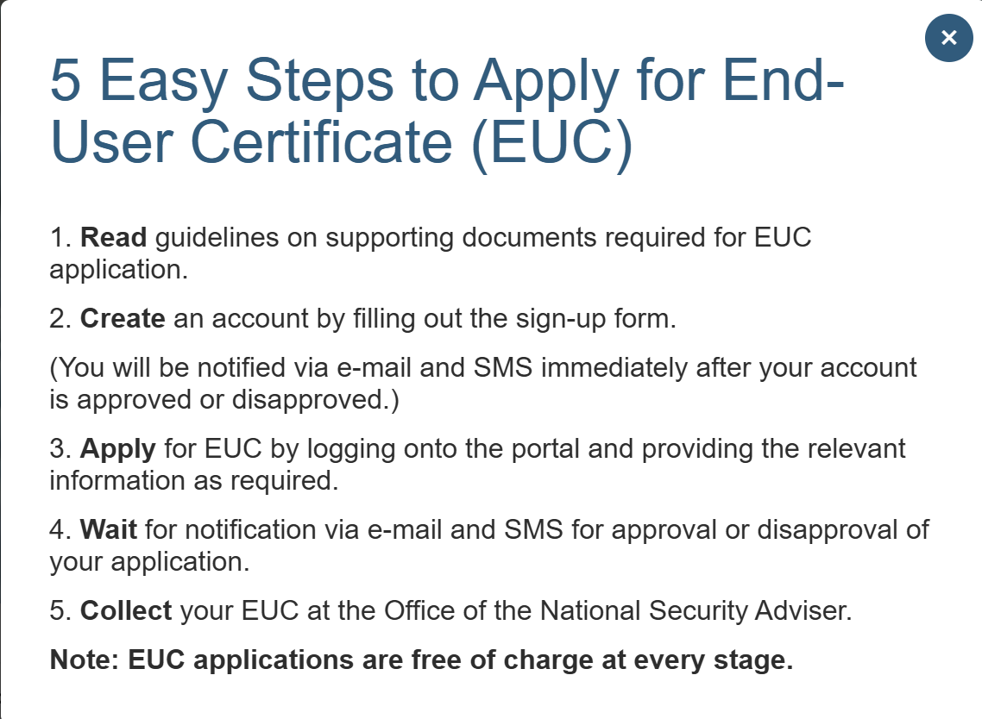
(I should probably order asap and figure out the documents as we go, one issue is going to be the drone piloting license… it might take time to get

